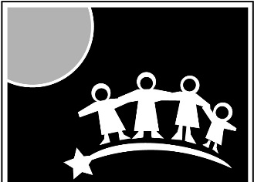
CCS
EARLY LEARNING
Making a difference in the lives and families of
young children within our communities

VACANCY ANNOUNCEMENT

Date: April 1, 2019 Open until filled

INFANT TODDLER CLASSROOM AIDE (5 positions)– Assists the teacher in providing developmentally appropriate activities and care to promote the health, nutrition, education and safety of the children.

MINIMUM QUALIFICATIONS:
- Six months experience caring for preschool children preferably in a classroom environment
- High school diploma or GED
- Ability to work as team member with staff and parents
- Ability to lift and carry 50 pounds
- Flexibility to work additional hours appreciated

EMPLOYMENT REQUIREMENTS:

Pre-hire: Fingerprinting/Background Check
Post-hire: Annual Physical/Health History
CPR and First Aid Certification
Food Worker Card
Current Auto Insurance Card

GENERAL INFORMATION:
Location: Palmer
Supervisor: Center Coordinator
Schedule: Part-time (24 hrs/wk) Monday – Friday, part-year (37.5 weeks/yr)
Summer and School breaks off.

Salary: $12.50-14.50 per hour DOE
Plus benefits- medical, dental, & life insurance, professional development opportunities, paid leave and holidays, retirement plan with matching contribution

To Apply: Submit resume and application to
cgruver@ccsalaska.org or jdunivan@ccsalaska.org
Or Mail to: CCS Administrative Office, 2060 E. Industrial Dr. Wasilla, AK 99654
Or Fax to 907-373-7020

For more information or to download an application visit www.ccsalaska.org

CCS Early Learning is an Equal Opportunity Employer

