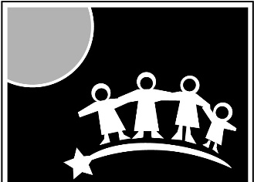
CCS
EARLY LEARNING
Making a difference in the lives and families of
young children within our communities

VACANCY ANNOUNCEMENT

Date: March 26, 2019 Open Until Filled

Professional Development Specialist – Support the implementation of high-quality teaching and instructional practices to enhance the impact of teacher-child interactions to achieve positive outcomes for children. Use research-based strategies to support adult learning and professional development of teachers (all classroom staff). Manage agency efforts to support trauma informed care.

Minimum Requirements
- Bachelor degree in early childhood education or related field required.
- Minimum 5 years of teaching experience in early childhood.
- Knowledge of adult learning principles.
- Experience providing and implementing early childhood education service activities and training for teaching staff or parents
- Pass a State and Federal Background Check

General Information
Location: Based at the Administrative Office in Wasilla with travel to all CCS locations
Supervisor: Tabatha Peterson, Programs Director
Schedule: Full-time 40 hours per week, 48 weeks per year
Salary: $24 - $27 per hour DOE/E
plus benefits - medical, dental, & life insurance, professional development opportunities, paid leave and holidays, retirement plan with matching contribution

To Apply: Submit resume and application to
cgruver@ccsalaska.org or jdunivan@ccsalaska.org
Or Mail to: CCS Administrative Office, 2060 E. Industrial Dr. Wasilla, AK 99654
Or Fax to 907-373-7020

For more information or to download an application visit www.ccsalaska.org

CCS is an Equal Opportunity Employer

